LNESC Albuquerque

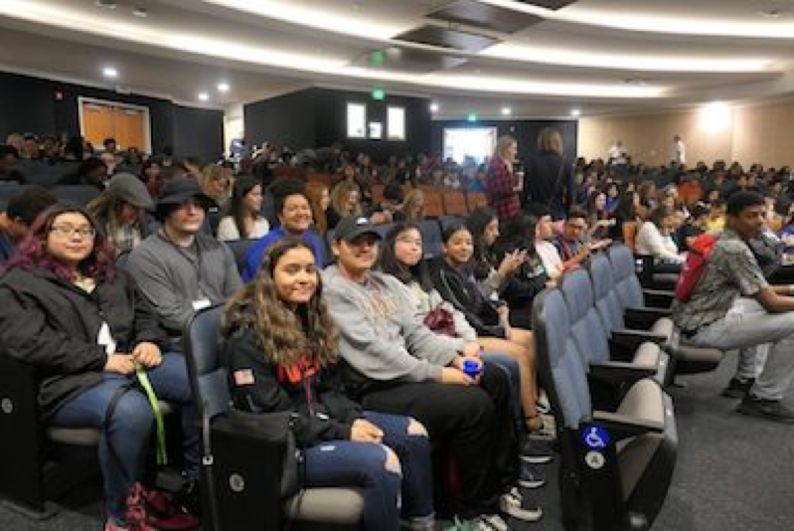

LNESC Albuquerque Upward Bound students spent their March Saturday Academy participating in the New Mexico Youth Celebrate Diversity Conference (NMYCD). High School students from all across New Mexico came out to CNM Main Campus to learn about and discuss a variety of social justice topics. Each workshop covered a different social justice topic that was selected by New Mexican teens such as homelessness, LGBTQ, suicide prevention, male privilege, the meaning of the Zia symbol and much more.
The conference was a great opportunity for all the students and adults that were able to attend. It was set up as a structured safe space for New Mexican youth to ask questions and learn about the vast amount of diversity right in their backyards.

For more information on LNESC Albuquerque visit their website!

